**DATE:**

**TASK6: LINEAR REGRESSION**

**AIM:** Program to implement Linear Regression for a data set.

**Dataset**: Iris Data

**Source**: UCI Repository

**LINEAR REGRESSION:**

It is one of the most widely known modelling technique. Linear regression is usually among the first few topics which people pick while learning predictive modeling. In this technique, the dependent variable is continuous, independent variables can be continuous or discrete, and nature of regression line is linear.

Linear Regression establishes a relationship between dependent variable(Y) and one or more independent variables(X) using a best fit straight line(also known as regression line).

It is represented by an equation Y=a+b*X+e, where a is intercept, b is slope of the line and e is error term. This equation can be used to predict the value of target variable based on given predictor variables.

**PROGRAM:**

**>x=c(151,174,138,186,128,136,179,163,152,131)**

**>y=c(63,81,56,91,47,57,76,72,62,48)**

**>plot(x,y)**

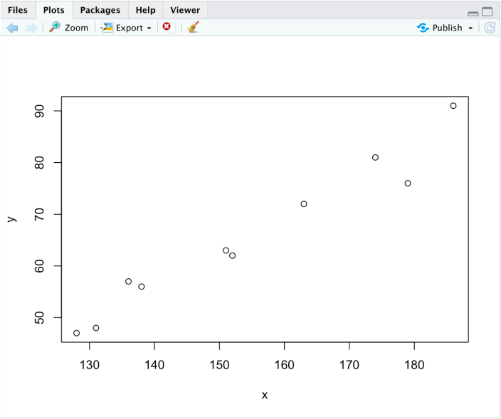

**>d=lm(y~x)**

**>print(d)**

Call:  
lm(formula = y ~ x)  
  
Coefficients:  
(Intercept)            x    
   -38.4551       0.6746

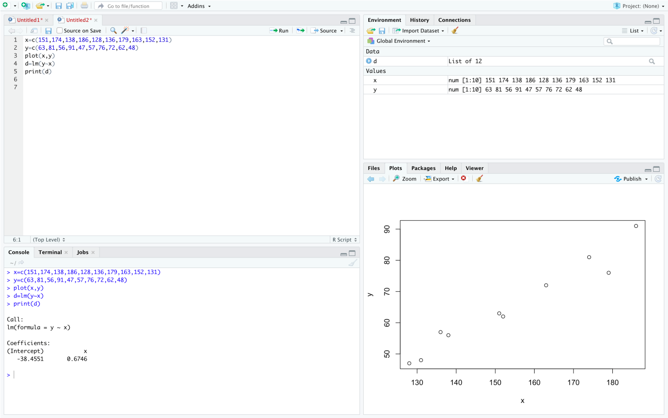  
  
**> summary(d)**  
  
Call:  
lm(formula = y ~ x)  
  
Residuals:  
    Min      1Q  Median      3Q     Max  
-6.3002 -1.6629  0.0412  1.8944  3.9775  
  
Coefficients:  
             Estimate Std. Error t value Pr(>|t|)      
(Intercept) -38.45509    8.04901  -4.778  0.00139 **  
x             0.67461    0.05191  12.997 1.16e-06 ***  
---  
Signif. codes:  0 ‘***’ 0.001 ‘**’ 0.01 ‘*’ 0.05 ‘.’ 0.1 ‘ ’ 1  
Residual standard error: 3.253 on 8 degrees of freedom  
Multiple R-squared:  0.9548, Adjusted R-squared:  0.9491  
F-statistic: 168.9 on 1 and 8 DF,  p-value: 1.164e-06

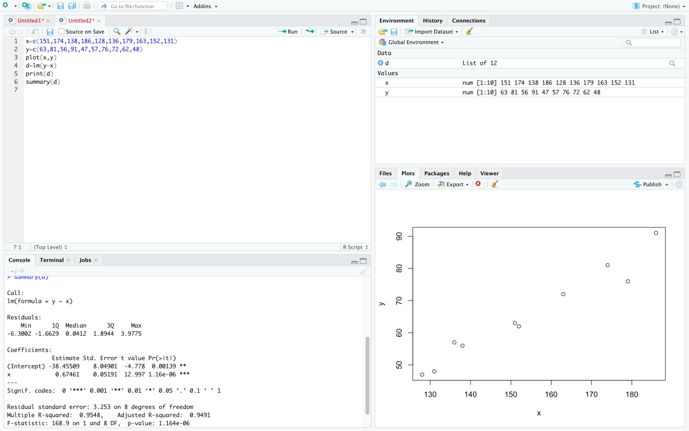  
 **> a=data.frame(x=c(168,177))  
> result=predict(d,a)  
> print(result)**  
       1        2  
74.87947 80.95096

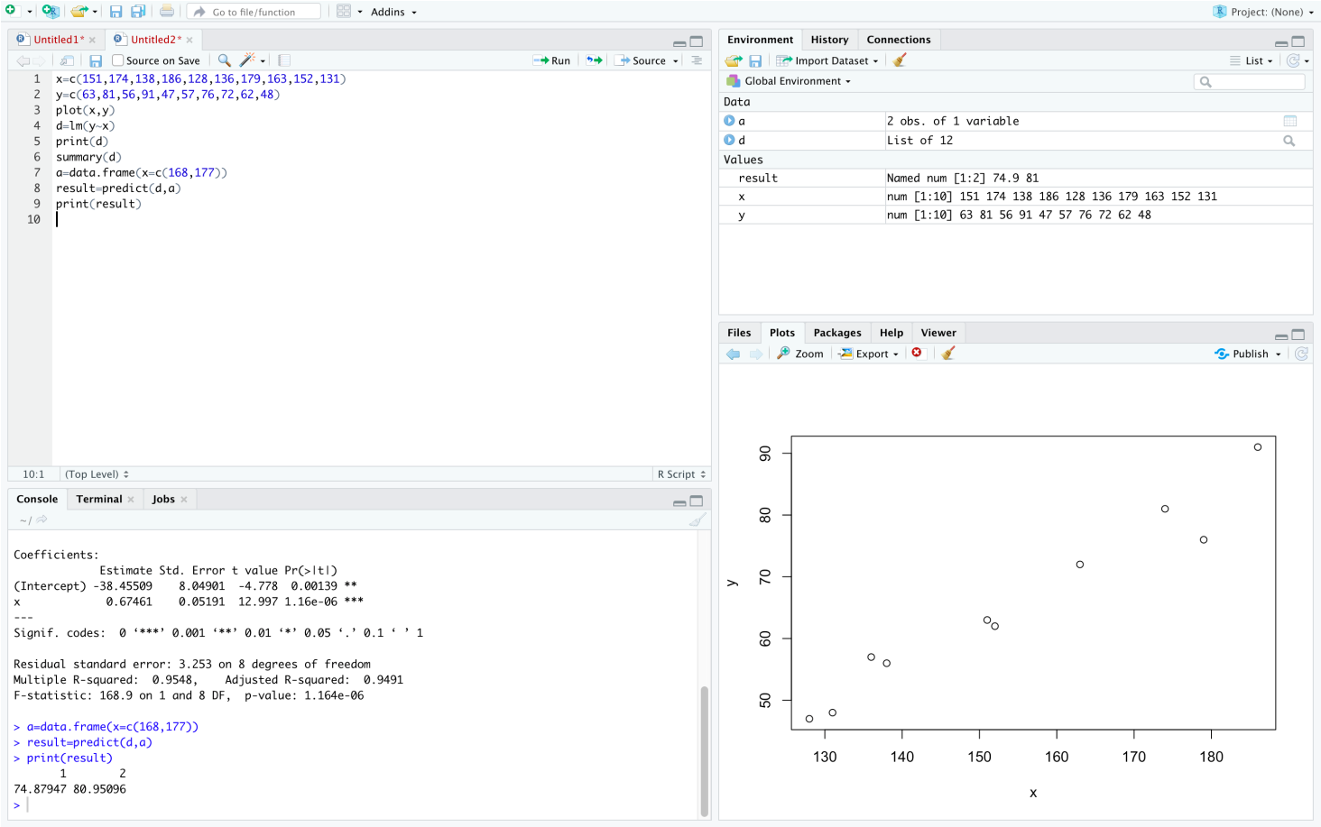

**>  
> plot(x,y,col="blue",main="Height & Weight Regression", abline(lm(y~x)),cex=1.3,pch=16,xlab="Height in cm", ylab="Weight in keg")  
>**

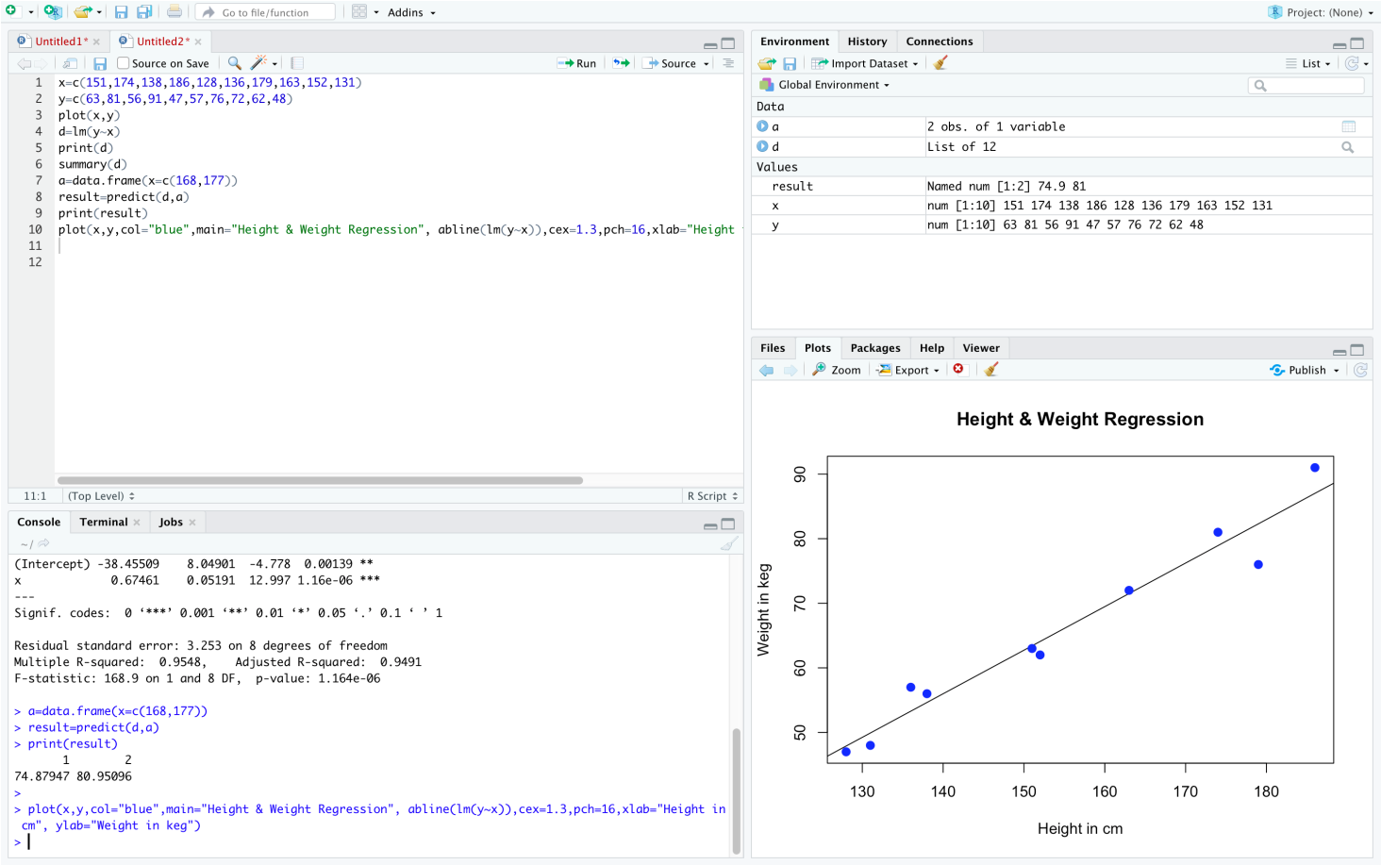

**RESULT:** The above program Linear regression is implemented successfully**.**